12th Grade Issues Voting Inquiry
What drives you to the polls?

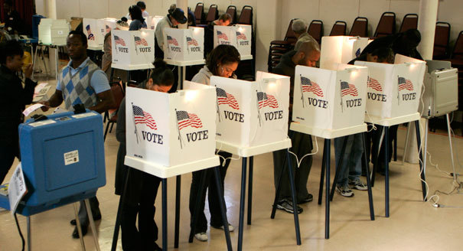

©politico.com

Supporting Questions
    - What are my political beliefs?
    - What are the major stances of political parties?
    - What are the views of the political candidates?

12th Grade Issues Voting Inquiry
What drives you to the polls?
Kentucky Academic Standards for Social Studies  & C3 Framework Indicator | HS2.CM.2 Analyze the civic responsibilities, democratic principles and constitutional rights that guide individuals and societies when addressing governmental and societal issues.
Staging the Question | Read What do Young Adults Know about Politics from civicyouth.org, then use Question Formulation Technique to generate questions about the trends of young adults and voting patterns.

Supporting Question 1 |  | Supporting Question 2 |  | Supporting Question 3
Student Research Opportunity |  | Understand |  | Understand
What are my political beliefs? |  | What are the major stances of political parties? |  | What are the views of political candidates?
Formative  Performance Task |  | Formative  Performance Task |  | Formative  Performance Task
Take a quiz on political beliefs and fill out a chart “From Beliefs to Voting” that explains the personal importance of those issues. |  | Add selected issues to the stances of the major political parties’ platforms on the “From Beliefs to Voting” chart and develop a claim about which political party best represents your beliefs on two selected issues. |  | Add selected issues to the stances of the major political parties’ platforms on the “From Beliefs to Voting” chart and develop a claim about which candidate best represents your beliefs on two selected issues.
Featured Sources |  | Featured Sources |  | Featured Sources
Source A: “Isidewith.com Political Quiz” |  | Source A: “Democratic Party Platform”  Source B: “Republican Party Platform”  Source C: “Green Party Platform”  Source D: “Libertarian Party Platform” |  | Source A: “Democratic Candidates websites”  Source B: “Republican Candidates websites”  Source C: “Third Party Candidates websites”  Source D: “2016 C-SPAN ‘Road to the White House’”

Summative Performance Task | ARGUMENT What drives you to the polls? Construct an argument (e.g., detailed outline, poster, and essay) that addresses the compelling question using specific claims and relevant evidence from contemporary sources while acknowledging competing views.
 | EXTENSION Select an issue and build a student belief continuum about the issue. Discuss how the major political parties or candidates fall along the continuum and whether there is a difference between party and belief.
Taking Informed Action | ASSESS Examine the extent to which one candidate and party views align to the issues important to you  ACT Do one of the following 1) Vote for a candidate based upon policy voting 2) Join a political party that aligns (or register independent) to your policy views. 3) Choose one of your key issues and join, support, champion its cause. 4) Develop your own form of action on the issue.

Overview

Inquiry Description
This inquiry leads students through an investigation of policy voting, i.e. aligning their own beliefs with policies of political parties and candidates. By investigating the compelling question students will research where the stand on their own beliefs, compare those beliefs to available political party platforms, then finally against candidates representing those parties (or running as independents). In investigating current issues, political party positions, and candidate positions, students will be better informed on which issues drive them to vote on election-day.

In addition to the Key Idea listed previously, this inquiry highlights the following Conceptual Understanding:
HS2.CM.2 Analyze the civic responsibilities, democratic principles and constitutional rights that guide individuals and societies when addressing governmental and societal issues.

N.B. While this particular inquiry focuses on the 2016 presidential election, it is constructed in such a way that it can be used for national and state election (both for primary and general). This inquiry is designed to take four, 60-minute class periods. The inquiry time frame could expand if teachers think students need addition instructional experiences (i.e. supporting questions, formative tasks, and featured sources). Teachers are encouraged to adapt the inquiry in order to meet the needs and interests of their particular students. For example, teachers will need to help students find credible websites that offer multiple perspectives based on students’ issues. Source credibility is a particular concern as misinformation concerning the issues could misalign a student to the opposing party or candidate. In addition, resources can be modified as necessary to meet individualized education programs (IEPs) or Section 504 Plans for students with special needs.

Structure of the Inquiry
In addressing the compelling question—“What Drive you to the Polls?”—students work through a series of supporting questions, formative performance tasks, and featured sources in order to construct an argument with evidence while acknowledging competing perspectives. In addition, students eligible to vote will take informed action and cast their ballot as they see fit.

Staging the Compelling Question
In staging the compelling question, “What drives you to the polls?” teachers may prompt students with the source “What do Young People Know about Politics?” then participating in a Question Formulation Technique (QFT) protocol wherein students will populate questions around a dual Q-Focus (Question Focus). The first Q-Focus is “Knowledge of Campaign Issues”, while the second is “My Political Beliefs” and both are aimed at connecting a generalized view of young people’s political behavior with their own—a self-check to reveal deeply held beliefs that may or may not lay beneath. This metacognitive exercise will get students thinking about their own beliefs leading them to begin researching issues important to them during the first supporting question.

Students’ questions likely will vary (especially on the second Q-Focus) but could include any of the following”
Q-Focus #1”Knowledge of Campaign Issues”
- What is considered a campaign issue?
- How do I find out more about campaign issues?
- How much knowledge must you have on a campaign issue to vote?
- What if I care more about some campaign issues than others, which is best?
Q-Focus #2 “My Political Beliefs”
- What are my political beliefs?
- Where do my political beliefs come from?
- Do I have to have political beliefs?
- Can I believe some things that opposing parties believe?

Supporting Question 1
The first supporting question—“What are my political beliefs?—helps students establish an introspective understanding of how their political ideology influences their political beliefs by examining how they feel about issues they may not know exist. The formative performance task asks students to research major political, economic, and social issues (at least six total: two for each of political, social, and economic questions), then fill out a chart, “From Beliefs to Voting”, detailing their issues and the explanations—backed with evidence—of these issues. This chart will scaffold across the entirety of the inquiry. Students will compile a list of issues and write a brief explanation for each of their positions to justify their positions (including acknowledging counter examples). Featured Source A: “Isidewith.com Political Quiz” is a quiz that enables to students to determine where they fall on political, economic, and social issues and how important those issues are to them. These issues ranging from educational to foreign policy will serve a palette from which to conduct research to help support why those issues are important.

Supporting Question 2
For the second supporting question—“What are the major stances of political parties?”—students build their knowledge of political party positions by analyzing Democratic, Republican, and the Third Party platforms presented by the Green Party and Libertarianism. Teachers are free to modify the number and types of third parties with possible selections including major third parties, i.e. Green Party of the United States, Libertarian, Constitution Party and single-issue parties, i.e. Prohibition Party and the Rent is Too Damn High Party (state only). The formative performance task asks students to fill out “From Beliefs to Voting” which continues to compare different political party platforms based on their initial six key issues, then develop a claim about which political party best represents their beliefs for two of their selected beliefs. There are three featured sources, which include each of the official platforms for each party investigated will help students investigate official party lines concerning the issues addressed in the first performance task. Alphabetically, the first is the Democratic Party platform, the second is the Republican Party platform, and the third is dependent upon teacher/student choice and regional concerns.

Supporting Question 3
For the third supporting question—“What are the views of political candidates”—students build on their knowledge of how they feel about particular political issues and where political parties stand on issues by examining individual candidates (e.g. for both primary and/or general elections). Depending on the context and timing of the inquiry, students can differentiate candidates within their primaries and against political opponents in the general election. The formative performance task asks students to finish filling out the chart “From Beliefs to Voting” by comparing and contrasting candidates’ views (of both/all parties) based on students’ issues, then develop a claim about which political candidate best represents their beliefs for two of their selected beliefs. The sources here are more precarious as they depend on the student’s issues and parties and on whether the teacher is focusing in on the primary and/or general election. Regardless, candidate websites and/or watching videos from “C-SPAN: Road to the White House 2016” students will investigate each of the candidate’s position comparing it to their own through the formative task.
Summative Performance Task

At this point of the inquiry, students have examined their own views on political issues, official party platforms, and individual candidates. Students should be able to use evidence to distinguish between political parties and differentiate between while contrasting those views with their own positions. In this task, students construct an evidence-based argument responding to the compelling question “What drives you to the polls?” It is important to note that students’ arguments could take a variety of forms, including a detailed outline speech, poster, or essay.

Students’ arguments likely will vary, but could include any of the following:
- The Republican Party’s candidate drives me to the polls because this candidate and political party closely aligns to my issues because I believe in smaller national government, the protection of gun rights, and fiscal conservatism.
- The Democratic Party’s candidate drives me to the polls because this candidate and political party closely aligns to my issues because I believe that the national government is best suited to address societal problems around gender inequality, wage stagnation, and abortion rights.
- Even though the likelihood of winning is low, the Third Party’s candidate and political platform drives me to the polls because he/she most closely aligns to my views on a single issue (immigration, abortion, gun control, consumer protection).
- There are no political parties or candidates that align to all my political views, therefore I am less inclined to endorse any party outright and will instead I am driven to the polls to vote for my favorite candidate who hold cross cutting views from all parties.
Students could extend their argument by participating in a class deliberation by building a belief continuum about students’ chosen issues. Students will discuss where political parties and candidates fall along this continuum defending their arguments with evidence. Students will try to distinguish the nuances between parties and their beliefs.

Students have the opportunity to Take Informed Action by first understanding their political options, which will be completed as students answer the second and third supporting question. Students will then assess which candidate or political party supports the issues important to them. Then students will have an option to vote for the candidate, join a political party, champion a favorite issue, and/or have the option to create their own action. The Taking Informed Action sequence begins at the stating of the inquiry, continues throughout the inquiry as students assess their options in the supporting questions, and culminates in taking informed action at the end of the inquiry.

Staging the Compelling Question
Featured Source | Source A: “What do Young People Know about Politics?” The Center for Information & Research on Civic Learning and Engagement (Circle).

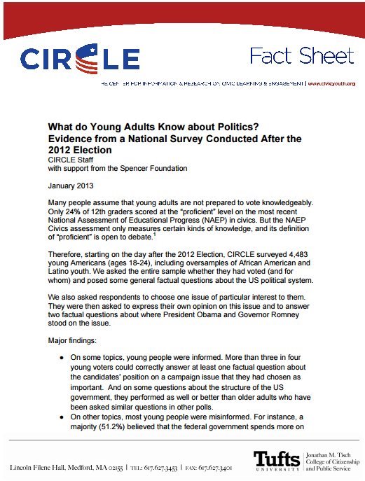

2013. The Center for Information & Research on Civic Learning and Engagement
http://www.civicyouth.org/wp-content/uploads/2013/01/What-Young-Adults-Know-Fact-Sheet-20131.pdf

From Beliefs to Voting
What Issues are important to you? | Issue Comparisons to Political Parties | Issue Comparisons to Candidates
Issue______________  Reasons for this belief | Political Party________________  Political Party________________  Political Party______________ | Candidate _____________________  Candidate____________________  Candidate______________________
Issue______________  Reasons for this belief | Political Party________________  Political Party________________  Political Party______________ | Candidate _____________________  Candidate____________________  Candidate______________________
N.B. For the total six issues, teachers will want to print multiple copies or copy and paste into googledocs.
Supporting Question 1
Featured Source | Source A: Isidewith.com, online quiz about political beliefs. “Political Quiz”, 2012

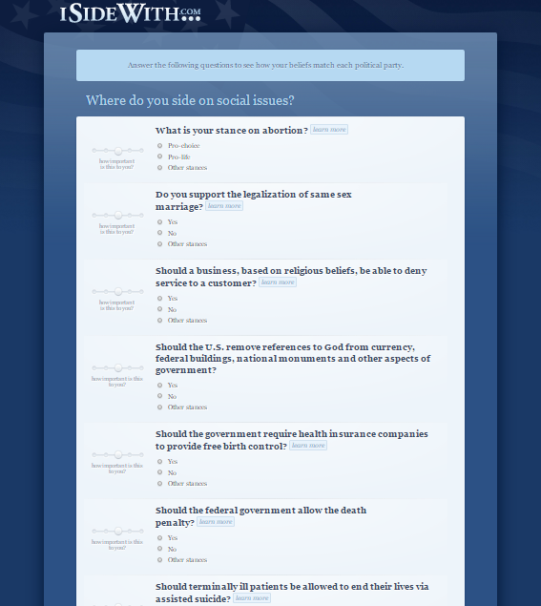

© 2011 http://www.Isidewith.com

Supporting Question 2
Featured Source | Source A: The Democratic Party Platform from the Democrat National Convention, 2016

https://www.demconvention.com/platform/

Supporting Question 2
Featured Source | Source B: The Republican Party Platform from the Republican National Convention, 2016

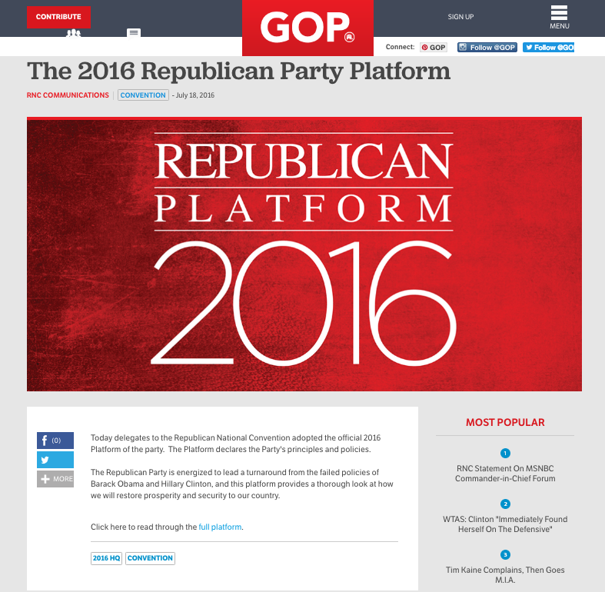

https://www.gop.com/the-2016-republican-party-platform/

Supporting Question 2
Featured Source | Source C: The Green Party Platform, 2016

http://www.gp.org/platform

Supporting Question 2
Featured Source | Source D: The Libertarian Platform, 2016

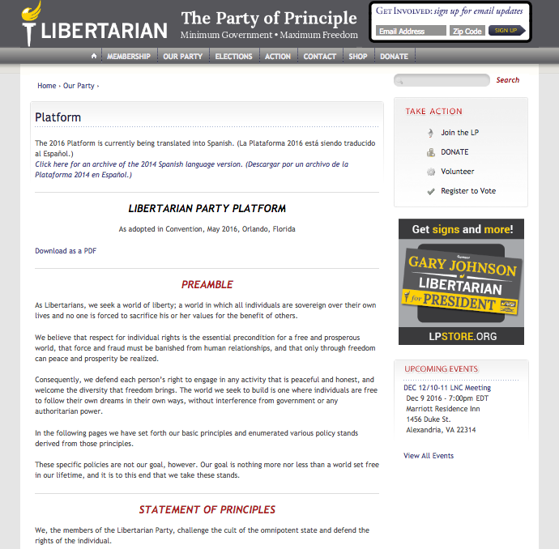

https://www.lp.org/platform

Supporting Question 3
Featured Source | Source A: Democratic Nominee, Hillary Clinton’s Campaign Website

https://www.hillaryclinton.com/home/

Supporting Question 3
Featured Source | Source B Republican Nominee Donald Trump’s Campaign Website

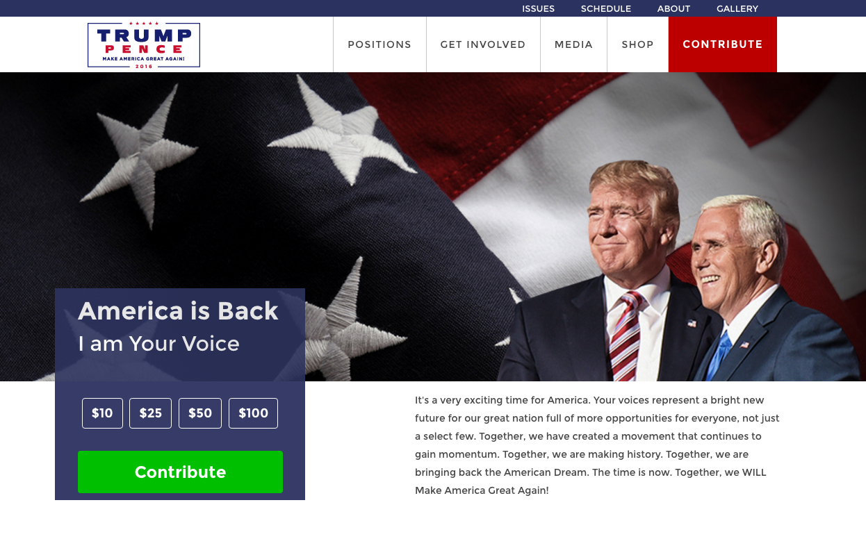

https://www.donaldjtrump.com/

Supporting Question 3
Featured Source | Source C Third Party Candidates from Green and Libertarian party websites detailing where they stand on the issues.

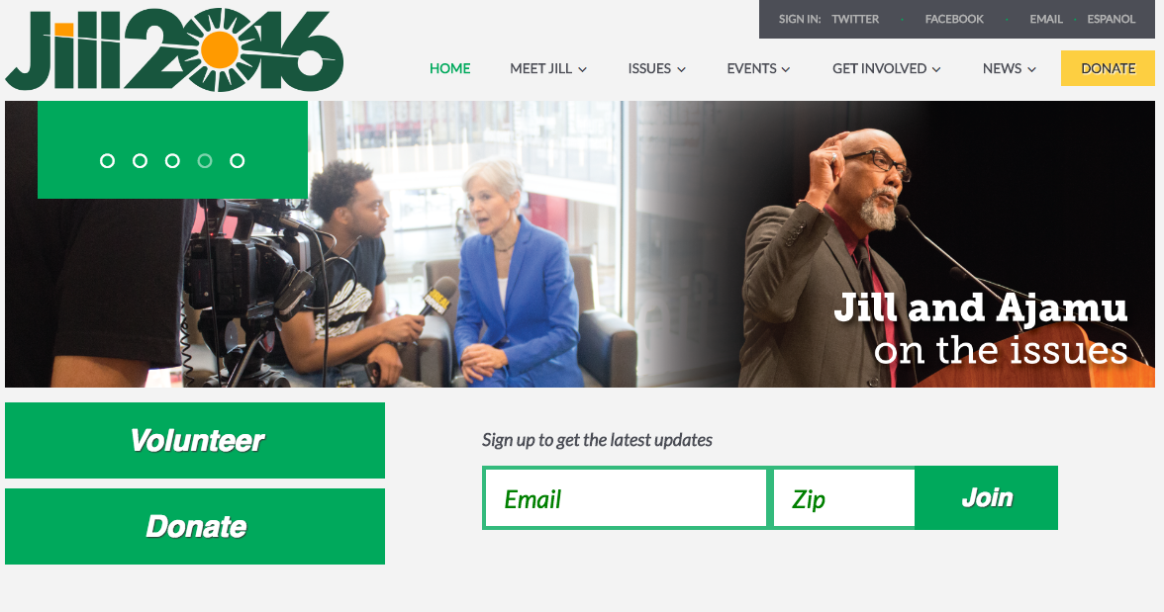

Green Party, Jill Stein http://www.jill2016.com/

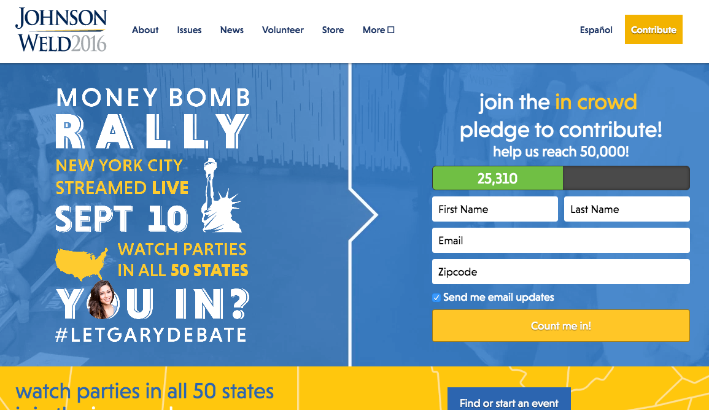

Libertarian Party, Gary Johnson https://www.johnsonweld.com/
Supporting Question 3
Featured Source | Source D C-Span Road to the White House, providing videos of candidates on select issues.

http://www.c-span.org/series/?roadToTheWhiteHouse

